## Problem 3 – Contact Us

Create a Web form (HTML5 + CSS3 + images) that looks and behaves like the screenshots below:

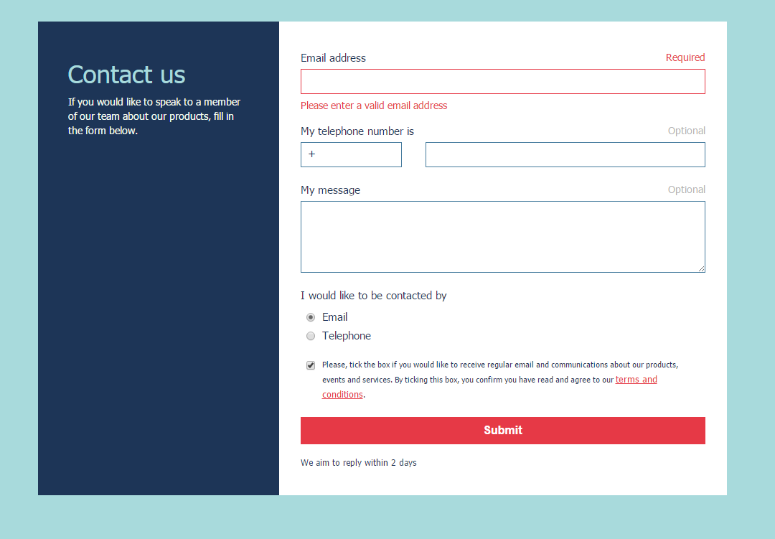

### Input

You are given the above screenshots and all required images.

### Output

The output should be valid HTML5 + CSS3 + images that implement the above Web form.

### Constraints

* Font: 15px/20px Tahoma, Helvetica, sans-serif.
* Title: 35px/60px, Subtitle: 13px, Button: 16px
* Content width: 960px;
* Colors: Red: #e63946 White: #f1faee Blue-Light: #a8dadc Blue-Dark: #1d3557
* Form validation is not required.
* The site should open correctly in Chrome 35.
* Responsive design is not required.
* Pixel-perfect implementation is not required.